- FolderScan.exe In NB012274.
- Double click on exe for run.
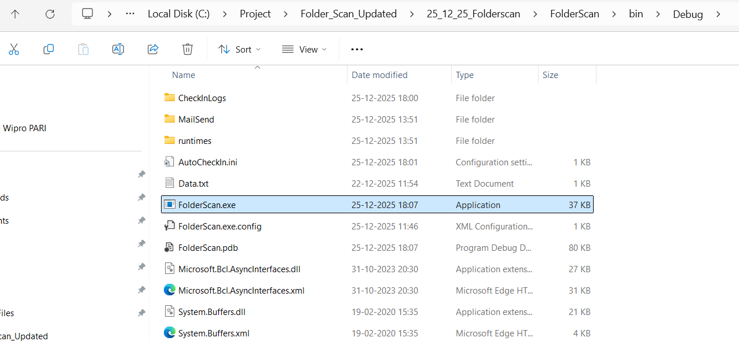

- After start exe below window is open
Directory Path : One Drive Sync Folder Path (current selected folder present in NB012274)
For browse folder click on .
Size : In KB for taking the ProjectData.zip folders
(If size is declare 24 kb then it take ProjectData.zip > 24kb only)
Default Octoplant check in bacup count is 1 currently declare inside code.
Input box for taking Octoplant check in project count form user is Pending.
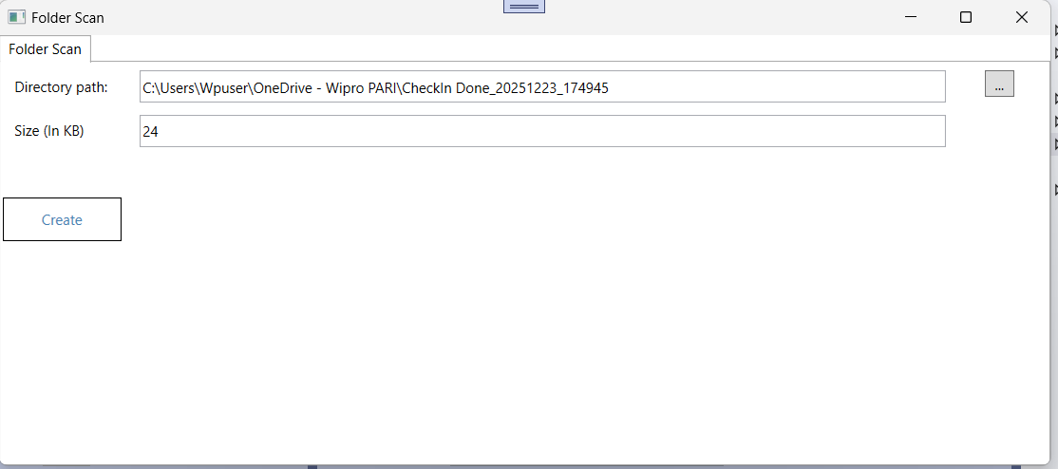

- CSV Generated After Running Folder Scan.
ProjectFolderList08_12_2025_10_14_31.csv : Contains Folder List (ProjectData.zip folder path), Date (Creation Date), Time (Creation Time).

Files08_12_2025_10_14_31.csv : Contains the Data Path Except this "ProjectData.zip", "Readme.txt", "SupplierChangeReason.txt", "SupplierComment.txt", "SupplierDeliveryNote.vdog-sdn".

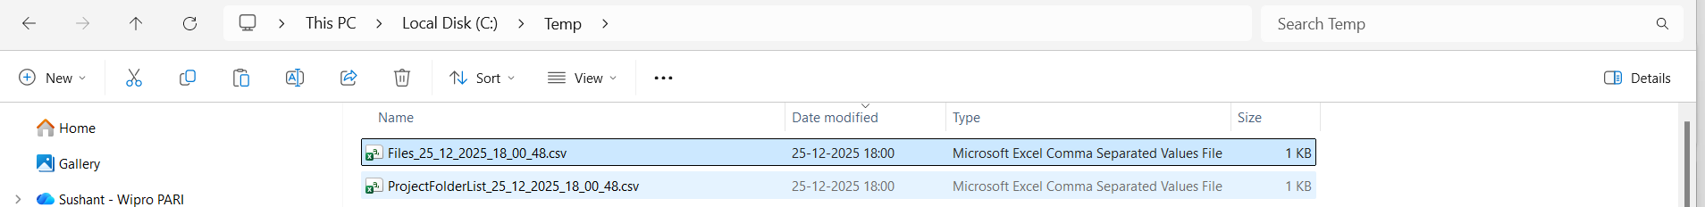
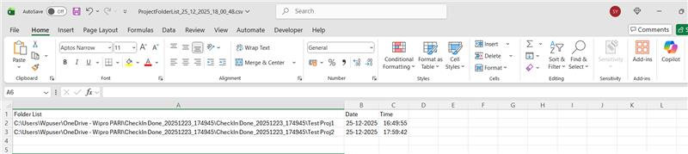

- Copy It in Local Folder
(For Extract the ProjectData.zip)
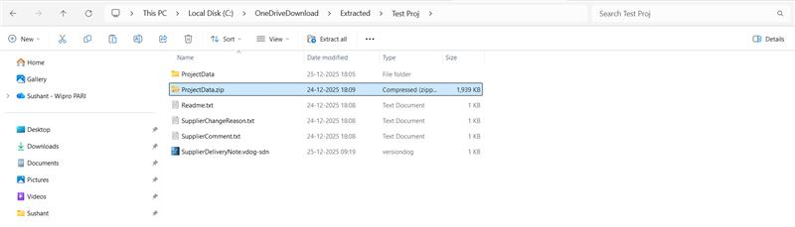
- Octoplant Component Check-out
(Check out Octoplant Component Mention in SupplierDeliveryNote.vdog-sdn file <Dir> tag)
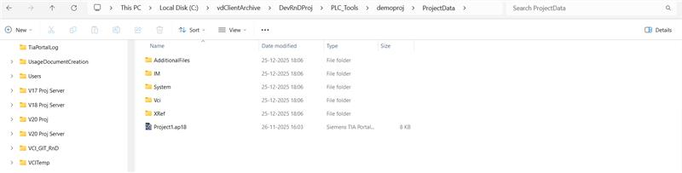

- Octoplant Component Check-In
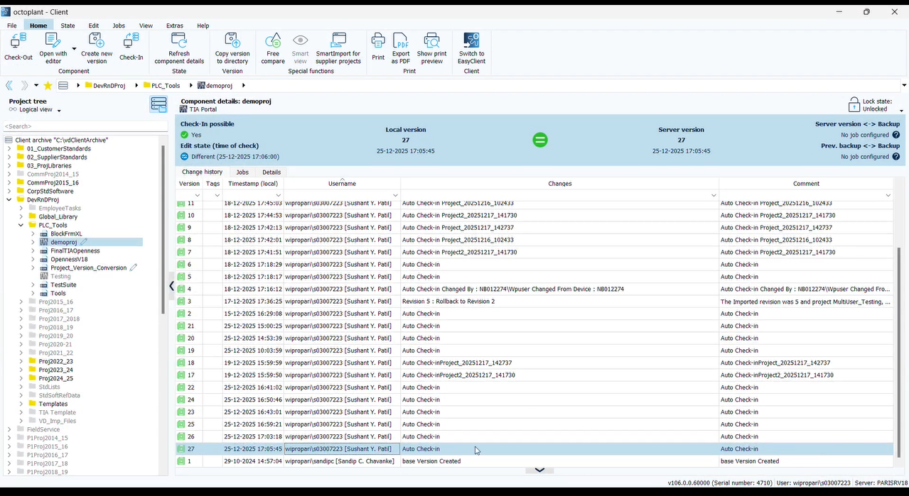

- Log File Generated After Successful Check-In
(Contains Component(Octoplant Checkin Component Path), Project (Project Folder Name), DateTine(checkin date and time))
After Octoplant check-in, the newly created version count is pending to be added to the log CSV file.
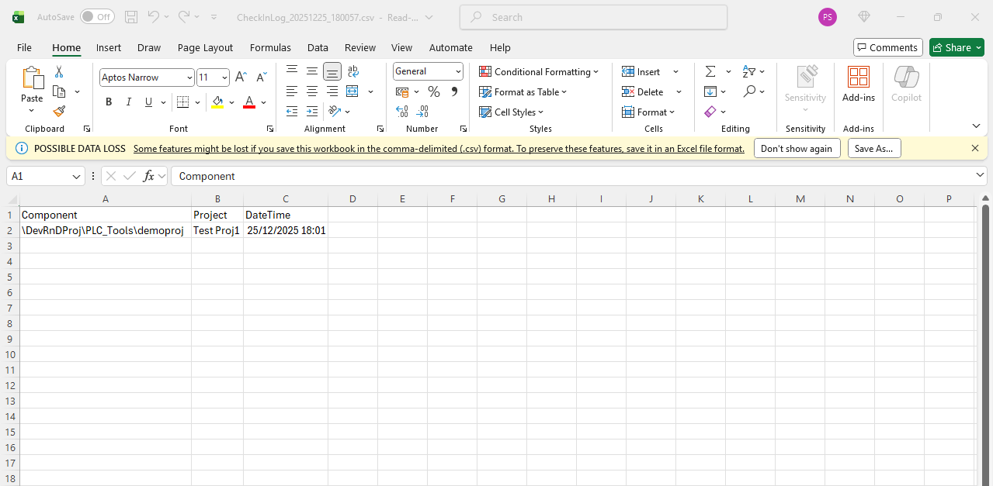

- Mail Sent With Check-In Log Report
(take mail id form " FolderScan Tool Path\ Debug\MailSend\Recipients.csv")

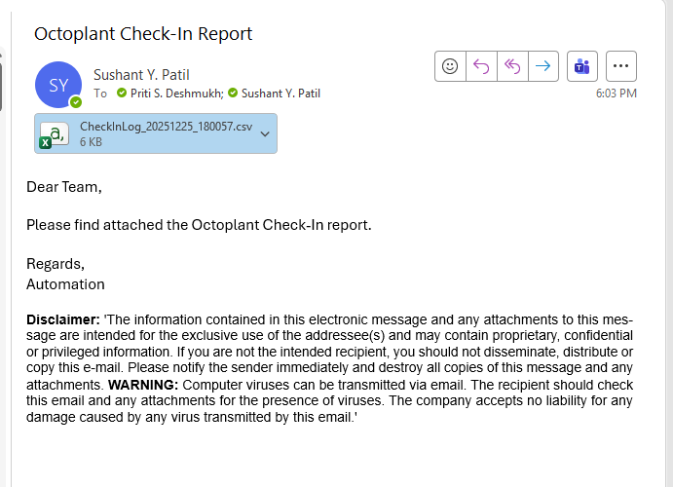

- Project Deleted From Local Folder which is used to extract zip folder

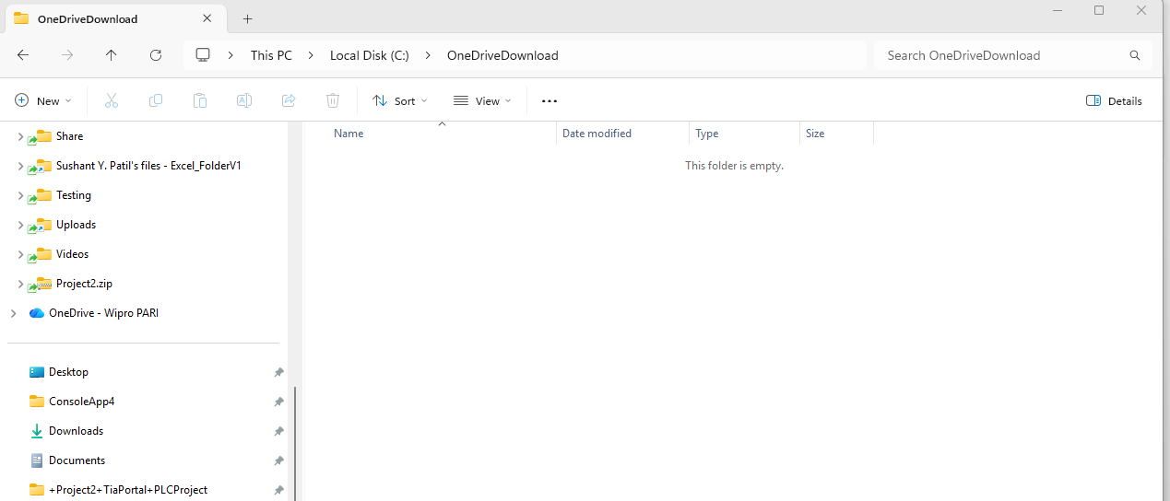

- Move Check In Completed Foder in “Old” Folder
(If Old folder is not present the create)

